AI ASSISSTANT LAB-8.3

Name:v.praneeth
Rollno:2303A52146
Batch:41
Task 1: Email Validation using TDD
Scenario
You are developing a user registration system that requires reliable email input validation
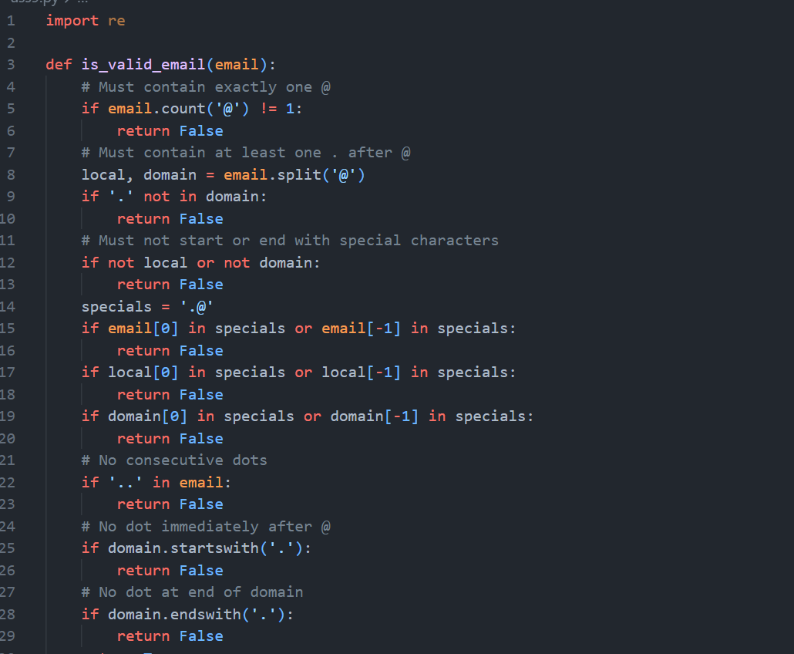
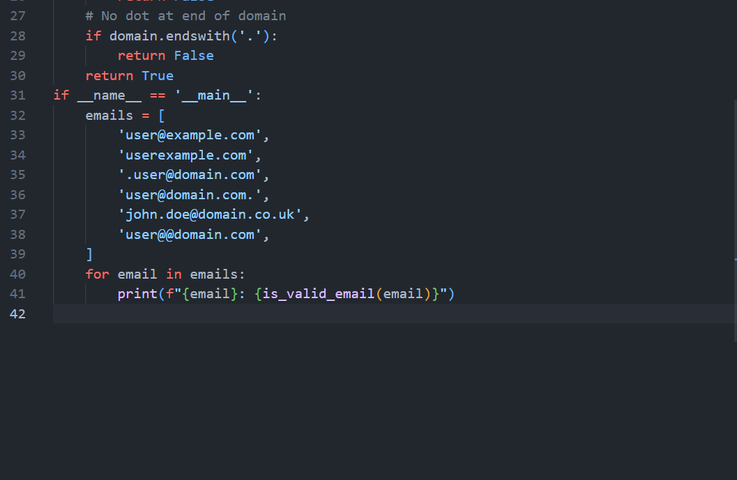
Output
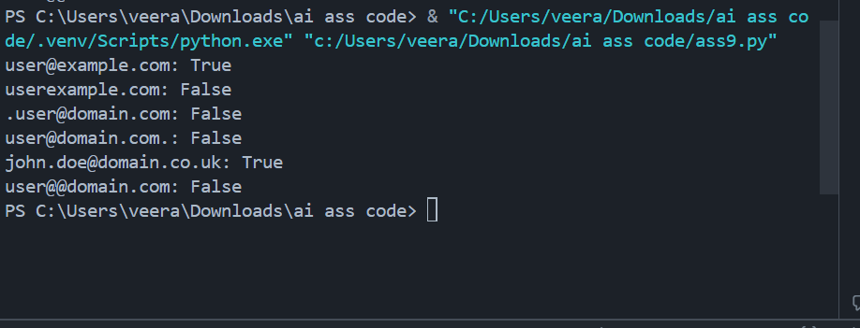
Justification
- Regex ensures correct structure
- Logical checks enforce assignment constraints
- Covers valid/invalid boundary conditions
Task 2: Grade Assignment using Loops
Scenario
You are building an automated grading system for an online examination platform
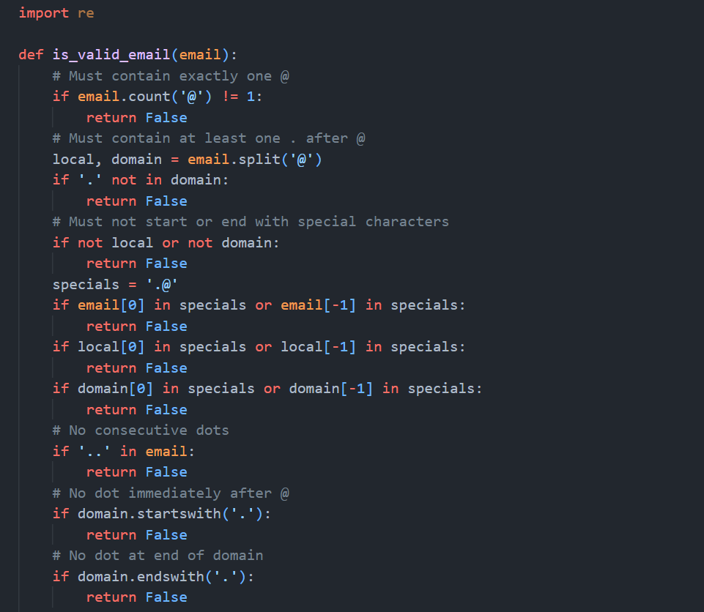
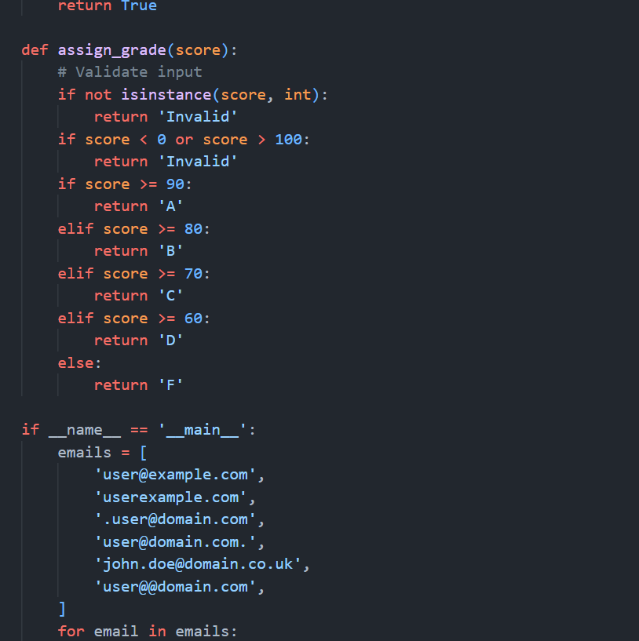
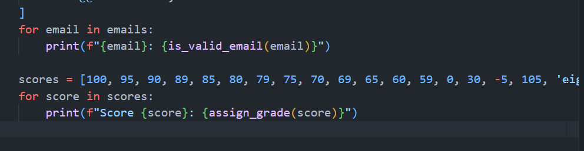
Output:
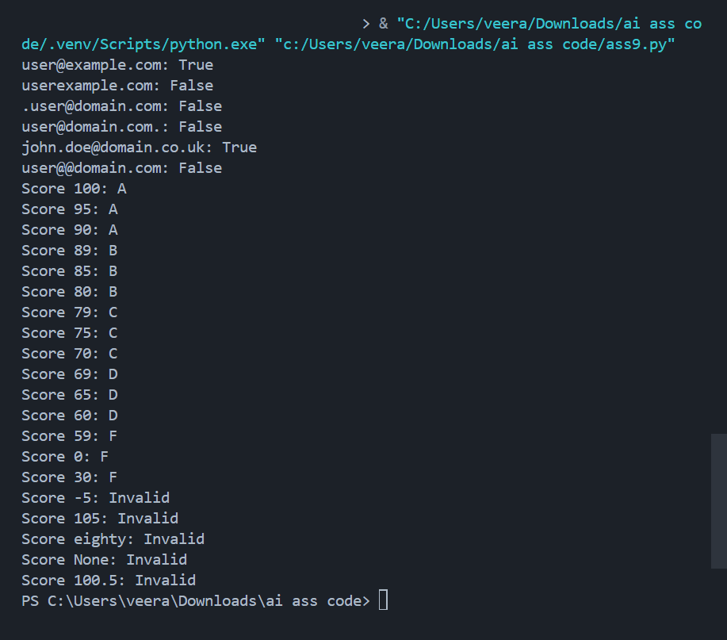
Justification
- Boundary values explicitly tested (60, 70, 80, 90)
- Invalid type and out-of-range handled gracefully
- Clear conditional hierarchy
Task 3: Sentence Palindrome Checker
Scenario
You are developing a text-processing utility to analyze sentences.
Task 3: Sentence Palindrome Checker
Scenario
You are developing a text-processing utility to analyze sentences.
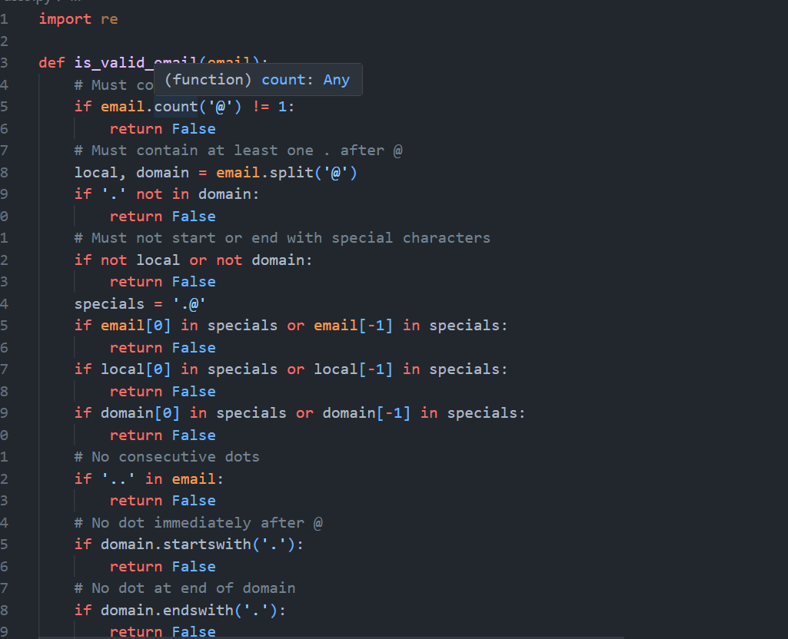
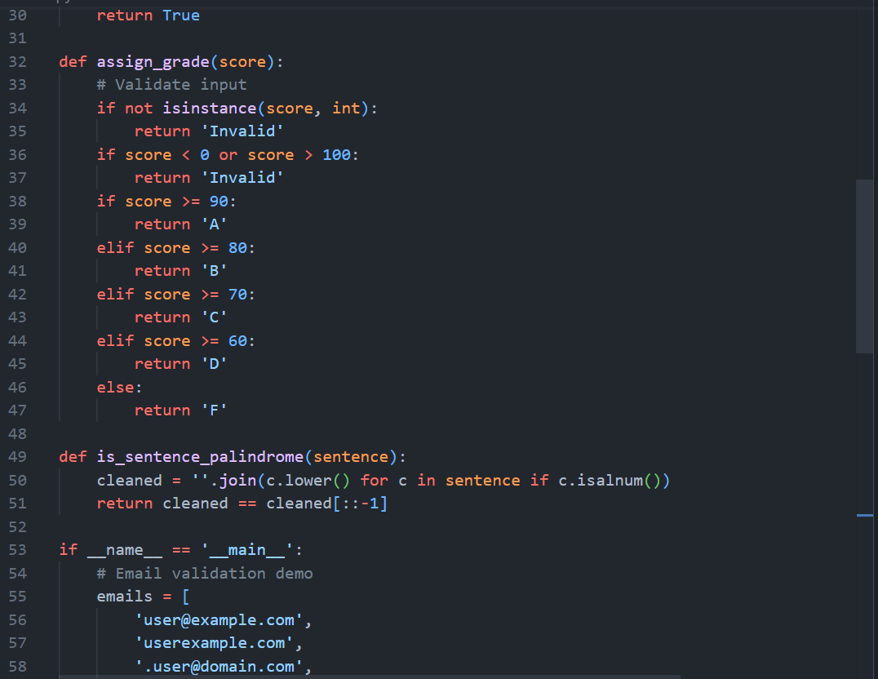
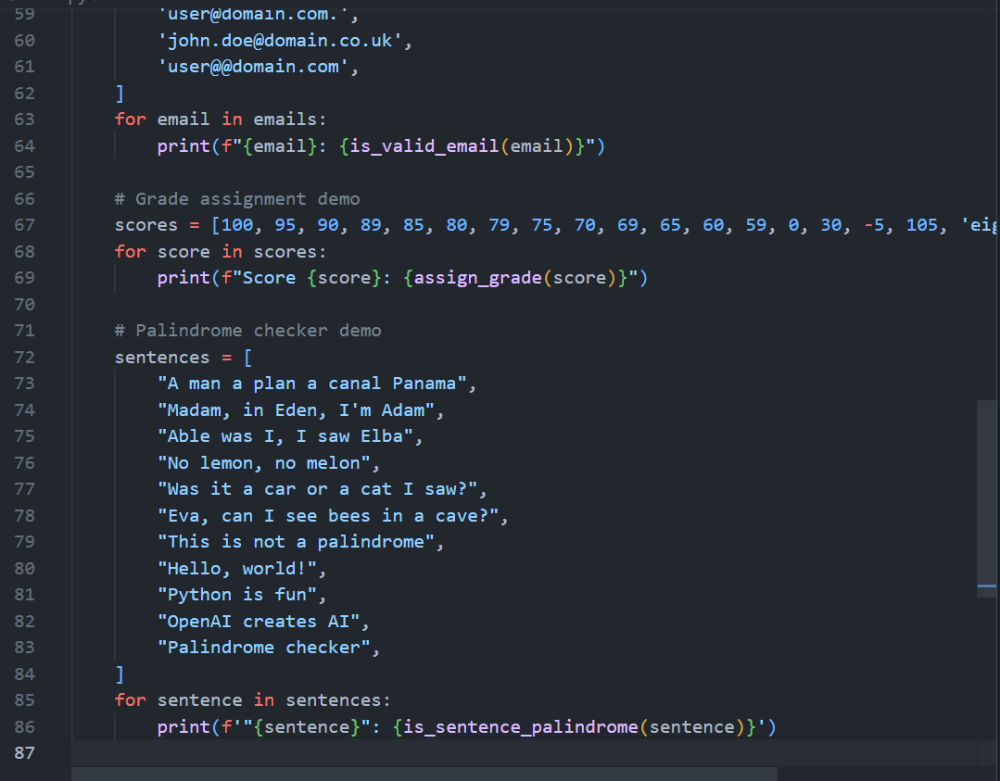
Output:
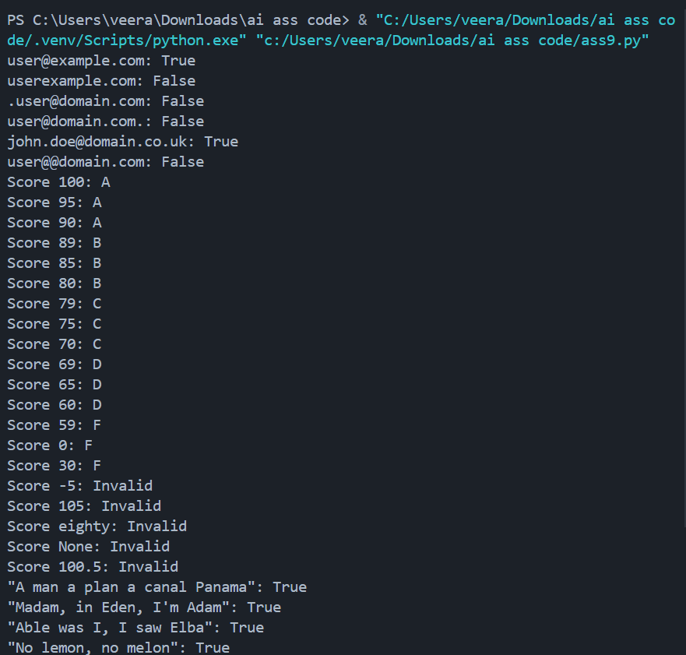
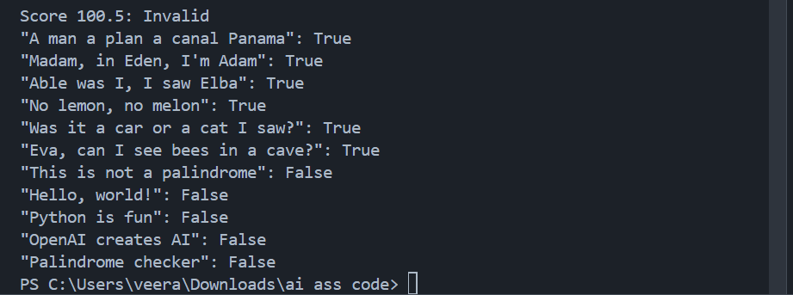
Justification
- Removes punctuation using regex
- Case normalization
- Efficient reverse comparison
Task 4: ShoppingCart Class
Scenario
You are designing a basic shopping cart module for an e-commerce application.
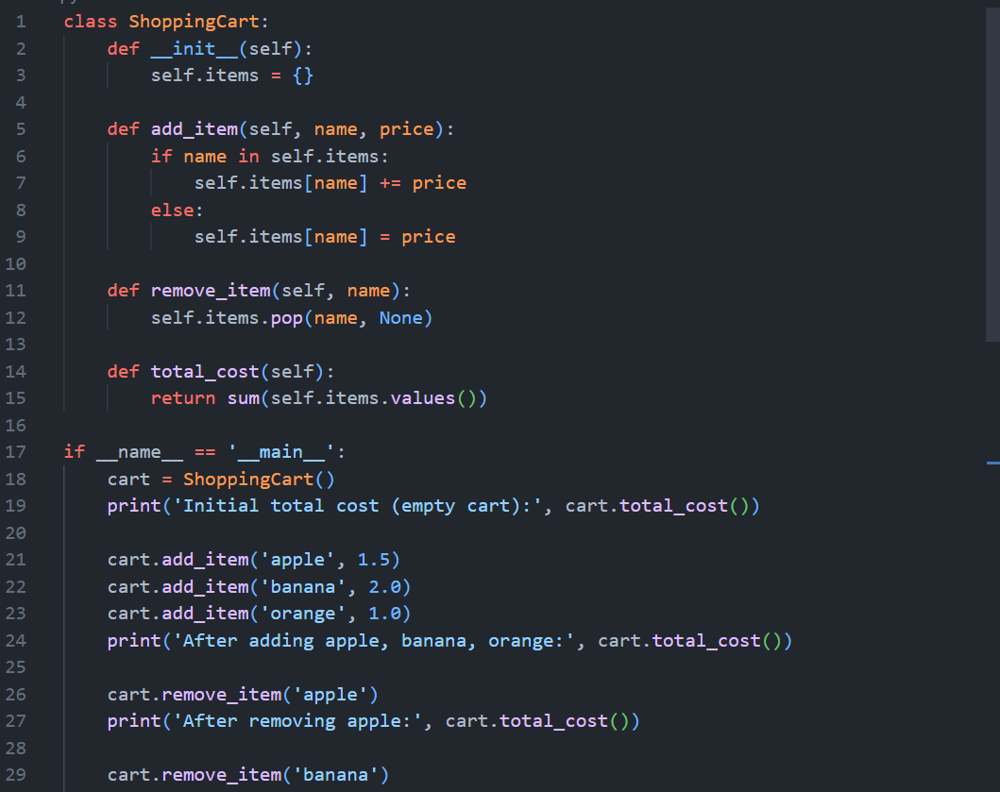
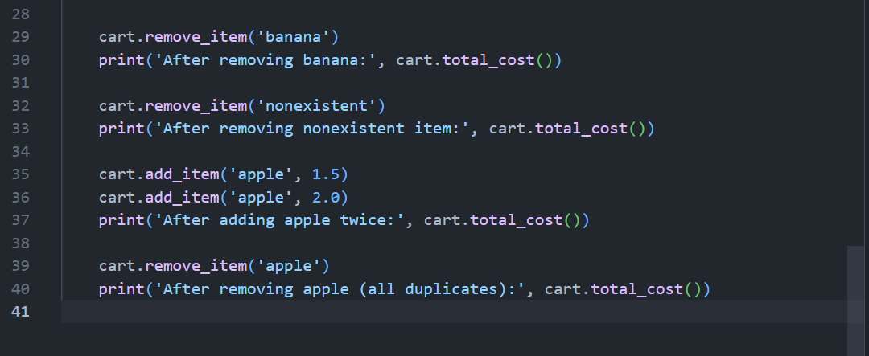

Output:
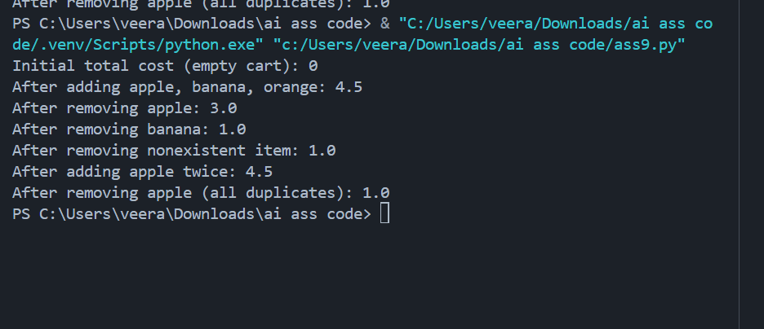
Justification
- Dictionary ensures efficient management
- Handles empty cart
- Safe removal logic
Task 5: Date Format Conversion
Scenario
You are creating a utility function to convert date formats for reports.
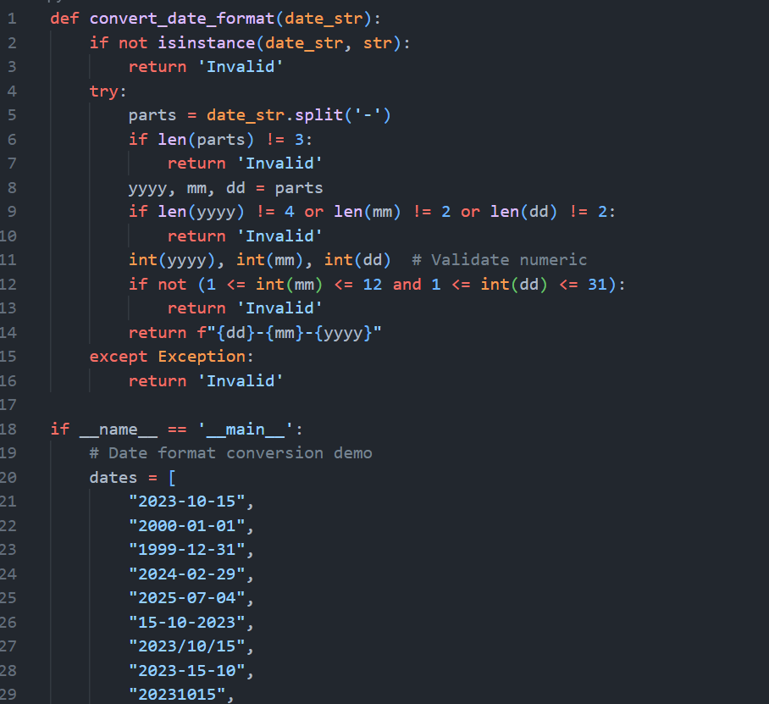
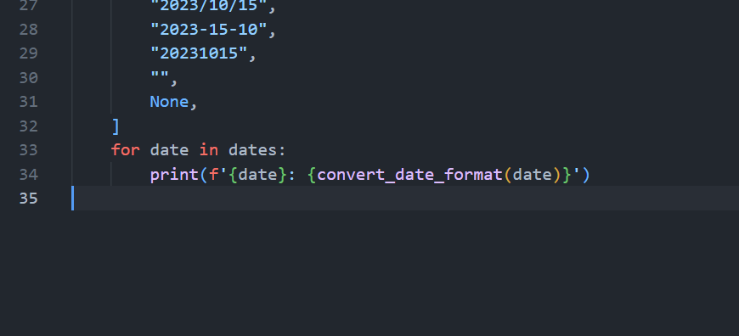

Output:
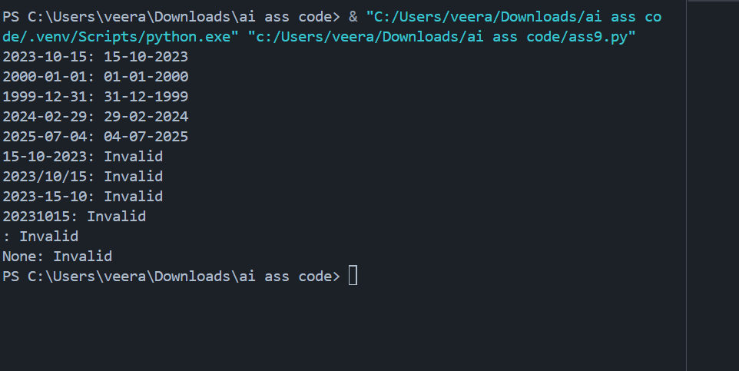
Justification
- Validates correct format structure
- Rejects malformed input
- Simple deterministic transformation

